THE AFRICAN DIGITAL COIN

*(STABLE COIN)*

*(ADC)*

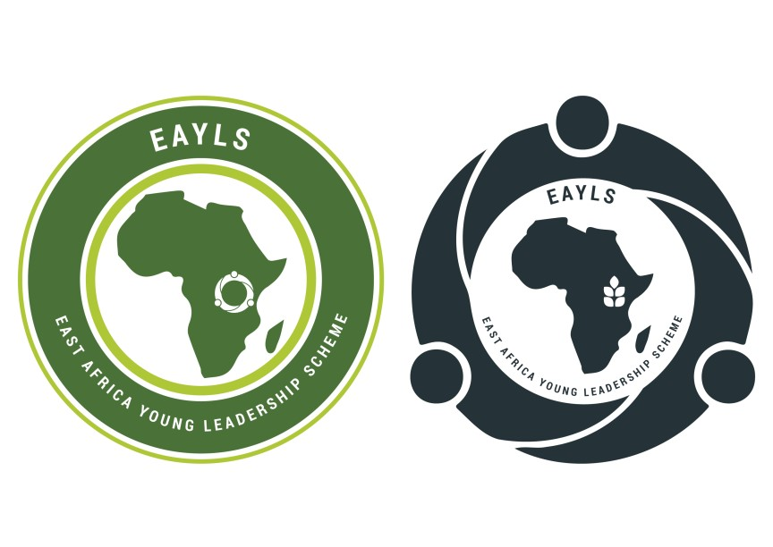

**THE ACCURATE STORAGE OF VALUE, WEALTH CREATION & SHARING.**

***A CONTINENTAL PAYMENT SYSTEM FOR AFRICA AND THE WORLD TOGETHER.***

PREPARED BY:

NSADHU MARVIN

5/23/2022

Contents

Foreword 4

INTRODUCTION 5

Currency. 6

Money. 6

The Gold Standard 7

EXECUTIVE SUMMARY 8

VISION 10

MISSION 10

OBJECTIVES 11

PRODUCTS AND SERVICES. 12

OPERATIONS PLAN 25

AFRICAN DIGITAL COIN TRADE AND MARKETS 26

GOLD BASE AND TRADE 26

AFRICAN DIGITAL COIN VALUE ORGANISM 27

COINAGE STRUCTURE AND VALUING ON GOLD 30

CREATION OF THE AFRICAN DIGITAL [AD] COIN PHYSICAL VALUE STRUCTURE AND VALUING. 31

Key: 31

PEGGING THE UGANDAN SHILLING ONTO THE AD GOLD COIN. 33

KEY: 33

WORKING 33

TAXATION 37

GOLDEN PEARL_ STOCK EXCHANGE. 38

FOREWORD 39

INTRODUCTION 40

EXECUTIVE SUMMARY 41

GPSE STOCK/SHARE VALUE AND PRICING MECHANISM 42

GPSE MATHEMATICAL VALUATION MECHANISM 42

FOREWORD 45

The apples of gold 46

Pictures of silver. 47

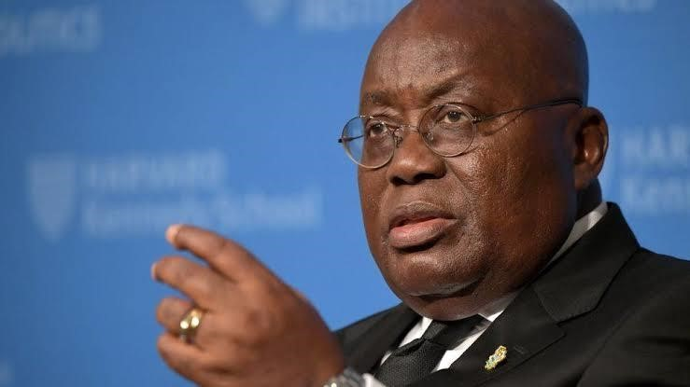

# Foreword

More than ever do we realize the need to contribute to the birth of the “United Africa”; which is the United States of Africa, we recognize than ever before the importance of the strength in unity of Africa; and we are working to shade that image of a helpless, happy-less continent.

There is a renewed commitment towards an inclusive and sustainable industrialization and economic integration and the intensity of the challenges we face today is only matched like never before by the immensity of the opportunity before us. We the current leaders of Africa should be determined not to waste a crisis before us.

(Ghana president Nana Akufo-Add United Nations Summit_2022)

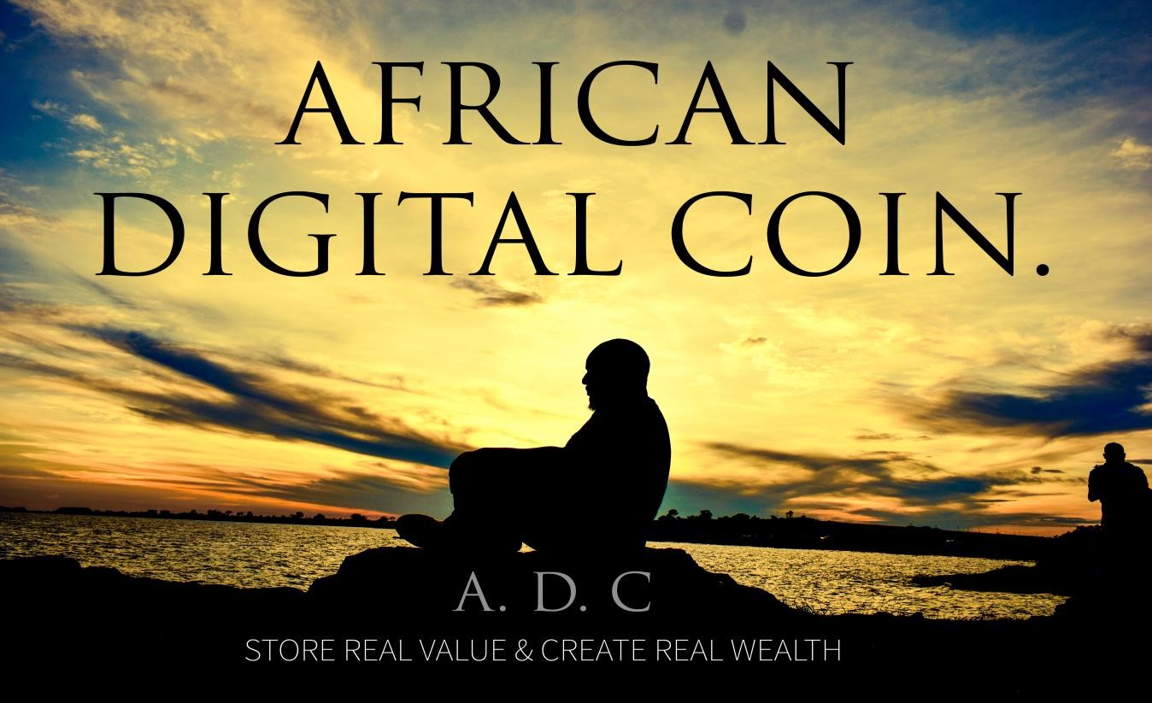

# INTRODUCTION

Throughout the history of civilizations an epic battle has always been waged, it is an unseen battle, unknown by most of the people it affects. Yet, all feel the effects of this battle in their daily lives. Whether it be at the supermarket when you notice that a liter of petrol [fuel] is 10% more higher than it was last time, you are feeling the effects of this hidden battle. This battle is between currency and money, and it is truly a battle of the ages. Most often this battle takes place between two natural resources gold and silver, and currencies that supposedly represents or once represented the value of gold and silver. Inevitably society always think that currency will win. They have the same blind faith every time, but in the end, the two natural recourses gold and silver always revalue themselves and they always win any financial battle.

To understand how gold and silver periodically revalue themselves and the financial systems of the world, you first need to know the differences between money and currency and throughout the ages many things have been currency; livestock, grains, spices, shells, beads, and paper/cotton paper have all been forms of currency, but only two things have been money: gold and silver.

## Currency.

A lot of people think currency is money. For instance, when someone gives you some cash, you presumably think of it as money. It is not. Cash is simply a currency, a medium of exchange that you can use to purchase something that has value, what we would call an asset.

Currency is derived from the word “current”. A current must keep moving or else it will die (think electricity). A currency does not store value in and of itself. Rather, it is a medium whereby you can transfer value from one asset to another.

### Money.

Money, unlike currency, has value within itself. Money is always a currency, in that it can be used to purchase other items that have value, but as we’ve just learned, currency is not always money because it doesn’t have value in and of itself. If you are having a hard time grasping this, just think about a hundred-dollar bill. Do you think that piece of paper is worth one hundred US dollar units of value? The answer is, of course, no. That paper simply represents value that is stored somewhere else—or at least it used to be before US ($) money became currency. Now all we need to know is that the U.S. dollar is backed by nothing other than hot air, or what is commonly referred to as “the good faith and credit of the United States.” In short, the USA government has the ability to, and has been, creating money at will without anything to back it up. We might call this counterfeiting; the governments through “economics” call it fiscal policy. The whole thing is what we refer to as “fiat currency”.

Fiat Currency

A fiat is an arbitrary decree, order, or pronouncement given by a person, group, or body with the absolute authority to enforce it. A currency that derives its value from declaratory fiat or an authoritative order of the government is by definition a fiat currency. All currencies in use today are fiat currencies. We see that it is the unexperienced economies and general public’s lack of understanding concerning this difference between currency and money that has created what Is happening as you read this paper, what is happening is the greatest wealth (Hidden value) accumulation opportunity in history; What we learn about currency and money is knowledge that probably 99 percent of the population has no clue about or desire to learn at the moment.

So in aspect of the global digital eco-system and ever growing digital financial frameworks, our proposed Gold-backed “African Digital stable-coin” redeemable in an actual gold(coin); the African financial system will be onward in the general knowledge about money and currency which will automatically result to a 360-degree true and positive mindset change on finance and economics then intensive integrated wealth creation, preservation and sharing on the African Continent and our dear international partners will be the norm.

**Inflation**

When I talk about inflation or deflation I’m talking about the expansion or contraction of the currency supply. The symptom of monetary inflation or deflation is rising or falling prices, which I will sometimes refer to as price inflation or price deflation. Regardless, one thing is for sure. With inflation everything gets more valuable except currency.

Why a Gold backed up digital coin for Africa?

## The Gold Standard

Gold, a natural resource which has captivated humanity for more than 5,000 years, it hasn't always been the basis of the monetary system. A true international gold standard existed for less than 50 years—from 1871 to 1914—in a time of world peace and prosperity that coincided with a dramatic increase in the supply of gold. The gold standard was the symptom and not the cause of this peace and prosperity, which was back then and gladly peace is being strengthened every day in the East African Community, one great advantage for the continent.

I believe the greatest investment opportunity in history is at our door. We can open it, or not . . . the choice is ours. For the past 2,400 years a configuration has continually repeated in which governments of old debase and dilute their money supply until a point where the common psyche of the populace and the collective mind of a country begin to feel that something isn’t right.

As the debasement progresses, the population senses the loss of their purchasing power. Then something miraculous happens. Through the free market system, the will of the public causes gold and silver to automatically revalue. In doing so, it accounts for all the currency that was created since the last revaluation. It’s automatic, and it’s natural; gold and silver have always done this, and they always will. People have an innate sense of the rarity of gold and silver. When paper money becomes too abundant, and thus loses value, man always turns back to the precious natural metals. When the masses come rushing back, the value (purchasing power) of gold and silver increases exponentially. During these events there is always an enormous wealth transfer, and it is within our power to choose whether it is transferred toward us, or away from us. If we choose to have it transferred toward us, then we must first educate ourselves, and second, take action.

Under a free-market system in the region and globe, gold in the East African Community should be viewed as a money and more needed than the euro, yen or U.S. dollar. Gold had a long-standing relationship with the U.S. dollar on which our Shilling laid it's back and over the long term, gold will generally have an inverse relationship. If we wait until disaster strikes, it may not provide an advantage if it has already moved to a price that reflects a slumping financial system.

# EXECUTIVE SUMMARY

The African Digital coin's attributes and intentions are to be Africa's continental currency, value store, digital bilateral trading and payment structure; established using the “Digital Stable coins” concept (a type of a digital currency). “Stable coins” are digital currencies recorded on distributed ledger technologies (DLTs), usually block chains, that are pegged (backed up) to a reference value. The majority of outstanding stable coins are pegged to the U.S. dollar, but stable coins can also be pegged to other fiat currencies, baskets of currencies, other cryptocurrencies, or commodities/assets such as Gold and SILVER. Stable coins serve as a store of value (A store of value is a commodity, asset, or money that retains its purchasing power or value into the future.) and a medium of exchange on Digital Ledger Technologies, which enable stable coins to be exchanged or integrated with other digital assets.

Stable coins differ from traditional digital records of money, such as bank deposit accounts, in two primary ways. First, stable coins are cryptographically secured. This allows users to settle transactions near-instantaneously without double-spending or an intermediary that facilitates settlements. On public block chains, this also allows for 24-hours-a-day/7-days-a-week/365days-a-year transactions.

Second, stable coins are typically built on Distributed Ledger Technology standards that are programmable and allow for the composability of services.

In this context, “composability” means stable coins can function as self-contained building blocks that interoperate with smart contracts (self-executing programmable contracts) to create payment and other financial services. These two key features underpin the current use cases of stable coins and support innovation the financial sector.

Stable coins stand in stark contrast with bitcoin, and most other cryptocurrencies, which have no inbuilt mechanism to minimize exchange rate volatility. While a number of novel valuation methodologies, Tether (USDT) - Exchange Rate and Market Value, 2015- to Present have been developed for crypto assets, and the debate over what a bitcoin should be worth carries on as strongly (and probably more strongly) today as it did in 2010 when bitcoin exchange markets first materialized. The marketplace for bitcoin, and its often volatile supply and demand forces, are what determine bitcoin’s price.

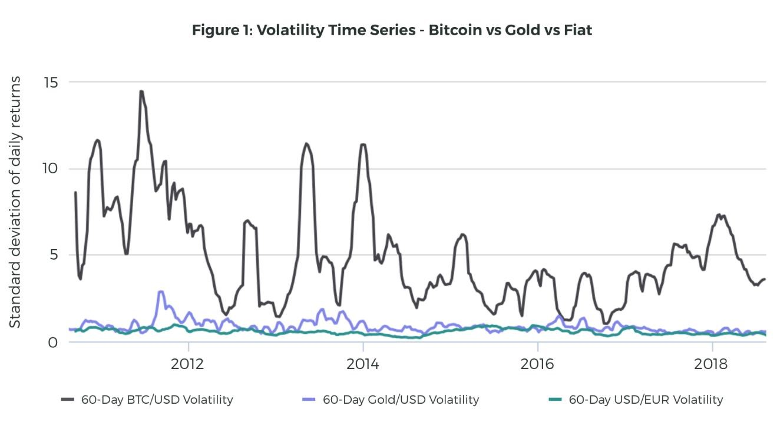

In contrast, the African digital stable coin is designed to be anti-volatile, with a 30-40% greater value than the performance line of Gold on the international market and ‘hard’ fiat currencies. A stable coin, serving respectively as a productive storage of value and medium of exchange and preferable for day to day use. Another important point to emphasize is that stable coins are simply price-stabilized cryptocurrencies, meaning they incorporate many of bitcoin or Tether’s most compelling features: programmability (e.g., smart contract integration), efficiency (e.g., low-to-zero transaction fees, fast settlement times).

### VISION

To make The East African community and Africa a global Digital financial center.

### MISSION

To create a natural continental and international payment system with a permanent storage of value.

### OBJECTIVES

* To plan and develop a state of the art industrial data infrastructure and value chain.
* To establish Gold and agriculture the overall storage of value of the continents financial eco system.
* To re-evaluate and peg our local fiat currencies with Gold.
* To establish a new international exchange currency in the East African community (Federation) and Africa.
* To enable the East African community and Africa obtain the leading gold currency reserve in the world.
* To provide a critical infrastructure layer for the African unlimited digital bilateral trading ecosystem.
* To curb and manage price volatility across the continental financial sector, agricultural sector and energy sector including all other vital divisions in the whole the East African economic region and Africa.
* To open further the East African market to unlimited and intensive continental and international trading opportunities.
* To expand digital payments and build a responsible digital payment ecosystem to fashion a smart and reliable agricultural sector (African Federal Bank engaging directly in the agriculture supply chain).
* To address the Continental and Global food insecurity by establishing the “African food Program”.
* To formulate a crystal clear value base for the agricultural sector in Africa.
* To guide in a new era of monetary innovation and encourage established institutions like our central banks to re-examine the nature and possibilities around one of our oldest institutions, money [Gold], and its role in the financial system.
* To reverse the effects of fiat currencies such as inflation and deflation throughout the whole Africa.
* To foster integrated industrialization in all sectors that need value addition throughout Africa.
* To abolish local and international faulty capitalistic monopoly in East African Regional markets and Africa.
* To ease, promote and enhance unlimited trade and investment throughout the East African region, Africa and international trade.
* To create an atmosphere for all industries in the East African region and Africa to engage in a “Gold solid” continental and global digital financial system and maximize their potential globally.

### PRODUCTS AND SERVICES.

The African Digital stable coin is a development meant to hover on top of the East African and African financial ecosystem, gold value chain, agriculture value chain, energy sector and the regional and international bilateral trade and markets; this is the only place it can live securely to maximize its full potential and impact the social and financial transformation of the East African community and Africa; making Africa the new international trade center. The products and services the African stable coin is to offer the following;

1. **Controlling and minimizing exchange rate price volatility;** maintaining stable economic value relative to African Gold reserve to create and maintain a reliable, sustainable and steadily progressive economic value, creating a healthy local and international digital trade and markets eco system with healthy and balanced competition in all sectors of the East African and African Market economy.
2. **Buying (at the international price) all the gold produced in the East African Community** and all the African countries that will partner, minting it into coins (30% VAT on every gram of the golden coin_66grams per coin); uploading minted coins into digital stable coins (East African Digital stable coin), selling the coins to the local and international Economy (we term them as investors)
3. **Engaging directly in the agriculture value chain;** Purchasing all the agricultural productions (at a fair and standard price; determined with integrity by the bank) in the East African region and other partnering African countries; agriculture production that is planted and cared for properly (organic manure and organic pesticides) the garden should be not less than an acre for single farmers{ registered farmers will offer timely updates digitally until the produce is purchased, the bank will supplements with inspectors}, offering real-time un-manipulated demand and supply data to farmers to help them make more reliable and productive decisions in farming and also encouraging smart agricultural cooperatives.
4. **Selling agricultural productions bought from the local farmers and cooperatives** to traders, wholesalers, agro processors and exporters through our open digital market that will connect all trade and markets stakeholders in single digital space, in real-time; aiding the logistics and storage of goods through an arm called the “African Food Program”.
5. **Selling Gold to exporters** (in minted coins only; charged for delivery charges and insurance).
6. **Organizing and monitoring digital trade of all locally produced energy** such as Hydro Energy, Oil and Gas on the African digital coin stocks market-the African digital coin will be the only currency used our stock market- the African Digital stable coin is the prosumer and the investors (people holding our digital coins) participate in a single auction and purchase energy on a day-ahead basis at a whole sale price; rewarding them(investors) a taxed profit percentage (accordingly to each one’s level of investment) after the final consumers purchase of the energy at the last market price.
7. **Organizing, aiding and promoting unlimited bilateral trade** in the East African and African economy and among our international trade partners; creating a digital single source platform, collecting all real-time trading opportunities in the seven states and build market closer economic relations between the Africa and our international partner.

**ORGANISATION STRUCTURE**

**AFRICAN**

**MONETARY**

**FUND**

**AMF**

**]**

**[**

**AFRICAN**

**FEDERAL**

**BANK**

**[**

**]**

**AFB**

**AFRICAN**

**FEDERAL**

**RESERVE**

**]**

**AFR**

**[**

**GOLD**

**BASE**

**AGRIC**

**BASE**

**UNLIMITED**

**BILATERAL**

**TRADE**

1. African monetary Fund.

Is the brain and nervous system of the financial system. It makes decisions and oversees the functioning of the entire system. The board of directors, consisting of heads of states or their ambassadors/governors, ensures that decisions are made in the best interest of the continent as a whole.

The integration of the East African Federation and its international developments Partners give an advantage and foundation of the African Monetary Funds’ instituting. The regional heads of state make up the executive committee of administrators of the Digital stable coin; the already existing protocol can be advanced accordingly and used to effectively administrate and monitor our Gold standard initiative throughout the whole entire continent and the world.

1. African Federal Bank & African Federal Gold reserve. The first “Bank” known to mankind was a secure facility where all valuable materials were kept for safety and security reasons in a community, in the early centuries when people acquired more material wealth such as gold, silver and all kinds of jewelry; to avoid buglers and bandits easy access to these precious items communities developed a solution to build this high security community vault. Every person who deposited their precious materials to the Bank where given “certificates of deposit,” “receipts,” or “claim checks” on the real treasure deposited in the Bank vault, this is what today we call “Bank notes or cash”. So in the beginning you had to take treasure in the bank to acquire “Bank note” and they could be exchanged for anything that the holder needs to purchase; from whom the purchase was made when they receive the “Bank notes” they are at will to go to the Bank and withdraw whatever treasure the Bank notes represented in the Bank vault or let it stay in the bank for security. So all Bank notes issued with no treasure or any material of value is an error that came in when men in power gave up on the integrity of the original banking core principles and values.

For the case of the African federal bank; As the central bank, it would be responsible for managing the monetary policy of the afflunomic system, similar to the way the heart pumps blood throughout the body. This includes regulating the money supply, setting interest rates, and ensuring the stability and integrity of the financial system. And the African federal reserve; Mandated as the resource reserve, storing excess resources for future use. This is akin to the liver's role in storing glycogen and some vitamins, releasing them when needed. In this financial system, this reserve can be used to stabilize the growth during times of financial downturn.

**Adventures in Currency Creation and monitoring. [US Dollar-case study]**

Societies usually start with high value commodity money such as gold and silver. Gradually, the government (America/US dollar) hoodwinked the population (local & international) into accepting fiat currency by issuing paper demand notes that are redeemable in precious metals. These demand notes (currency) are really just “certificates of deposit,” “receipts,” or “claim checks” on the real money that is in the vault. I would venture to say that many Americans think this is how the U.S. dollar works today. Once a government has introduced a paper currency, they then expand the currency supply through deficit spending, printing even more of the currency to cover that spending, and through credit creation based on fractional reserve banking. Then, usually due to war or some other national emergency, like foreign governments or the local population trying to redeem their demand notes (bank runs), the government will suspend redemption rights [Richard Nixon 1971] because they don’t have enough gold to cover all of the paper they have printed, and poof! You have a fiat currency that was or still is to some ill-informed people an international reserve currency.

Here’s the dirty little secret: Fiat currency is designed to lose and rob value. Its very purpose is to confiscate your wealth and transfer it to the government (America/US dollar). Each time the government prints a new dollar and spends it, the government gets the full purchasing power of that dollar. But where did that purchasing power come from? It was secretly stolen from the dollars you hold. As each new dollar enters circulation it devalues all the other dollars in existence because there are now more dollars chasing the same amount of goods and services. This causes prices to rise. It is the insidious stealth tax known as inflation, robbing you of your [international scale] wealth like a thief in the night.

Throughout the centuries, gold and silver have battled it out with fiat currency, and the precious metals have always won. Gold and silver revalue themselves automatically through the free market system, balancing themselves against the fiat currency in the process. This is a pattern that has been repeating and repeating since the first great currency crash in Athens in 407 B.C. Whenever an investor detects the beginning of one of these battles, the opportunities (according to history) to accumulate great wealth in a very short period of time are enormous. It always seems to start the same way. Energy builds as the currency supply is expanded, and then, through natural human instincts, the coming crash is felt by the masses, and suddenly, in an explosive move and in a short amount of time, gold and silver will revalue themselves to account for the currency that has been created. If you see the writing on the wall and then take action before the masses do, your purchasing power will grow exponentially as gold and silver grow in value relative to an inflated currency. If you don’t, you’re in for a wipeout.

These heavyweight bouts between fiat currency and gold and silver can end one of two ways:

The first, a technical decision, where the fiat currency surrenders’ and becomes an asset backed by gold or silver again.

Or:

Secondly a knockout blow that is the death of the fiat currency if it stands alone.

Either way, gold and silver are always declared the victors. They are always the reigning heavyweight champions of the world. But you don’t have to take my word for it. Let’s see what history has to say.

**It’s All Greek to Me**

Winston Churchill once said, “The farther backward you can look, the farther forward you are likely to see.” So in the spirit of Churchill, we are going to look back . . . way back to the time of the Greeks.

Gold and silver have been the predominant currency for 4,500 years, but they became money in Lydia, in about 680 B.C. when they were minted into coins of equal weight in order to make trade easier and smoother. But it was when coinage first made its appearance in Athens that it truly flourished. Athens was the world’s first democracy. They had the world’s first free-market system and working tax system. This made possible those amazing architectural public works like the Parthenon.

Indeed, for many years the Athens star shone brightly. If you’ve studied your history, then you know they are considered one of the great civilizations of all time. You’ll also know that their civilization fell a long time ago. So what happened? Why did such a great and powerful civilization like Athens fall? The answer lies in the same pattern we can see time and time again throughout history: too much greed leading to too much war. Athens flourished under their new monetary system. Then they became involved in a war that turned out to be much longer and far costlier than they anticipated (sound familiar?). After twenty-two years of war, their resources waning and most of their money spent, the Athenians came up with a very clever way to continue funding the war. They began to debase their money in an attempt to soldier on. In a stroke of genius, the Athenians discovered that if you take in 1,000 coins in taxes and mix 50 percent copper in with your gold and silver you can then spend 2,000 coins! Does this sound familiar to you? It should . . . it’s called deficit spending, and our government does it every second of every day.

This was the first time in history that gold or silver had a price outside itself. Before the Athenians’ bright idea, everything that you could buy was priced in a weight of gold or silver. Now, for the first time, there was official government currency that was not gold and silver, but rather a mixture of gold or silver and copper. You could buy gold and silver with it, but the currency supply was no longer gold and silver in and of themselves. Over the next two years their beautiful money became nothing more than currency, and as a consequence it became practically worthless. But obviously, once the public woke up to the debasement, anyone who had held on to the old pure gold and silver coins saw their purchasing power increase dramatically.

Within a couple of years, the war that had started the whole process had been lost. Athens would never again enjoy the glory they once knew, and they eventually became nothing more than a province of the next great power, Rome.

And the very first regional heavyweight bout between currency and money goes to the “real money,” as gold and silver are crowned the “Heavyweight Champions of Athens”.

**Rome Is Burning**

Rome supplanted the Greek empire as the dominant power of its day, and during its centuries of dominance, the Romans had ample time to perfect the art of currency debasement. Just as with every empire in history, Rome never learned from the mistakes of past empires, and therefore they were doomed to repeat them.

Over 750 years, various leaders inflated the Roman currency supply by debasing the coinage to pay for war, which would lead to staggering price inflation. Coins were made smaller, or a small portion of the edge of gold coins would be clipped off as a tax when entering a government building. These clippings would then be melted down to make more coins. And of course, just as the Greeks did, they too mixed lesser metals such as copper into their gold and silver. And last but not least, they invented the not so subtle art of revaluation, meaning they simply minted the same coins but with a higher face value on them.

By the time Diocletian ascended to the throne in A.D. 284, the Roman coins were nothing more than tin-plated copper or bronze, and inflation (and the Roman populace) was raging.

In 301, Diocletian issued his infamous Edict of Prices, which imposed the death penalty on anyone selling goods for more than the government mandated price and also froze wages. To Diocletian’s surprise, however, prices just kept rising. Merchants could no longer sell their wares at a profit, so they closed up shop. People either left their chosen careers to seek one where wages weren’t fixed, or just gave up and accepted welfare from the state. Oh yeah, the Romans invented welfare. Rome had a population of about one million, and at this period of time, the government was doling out free wheat to approximately 200,000 citizens. That equaled out to 20 percent of the population on welfare.

Because the economy was so poor, Diocletian adopted a guns and butter policy, putting people to work by hiring thousands of new soldiers and funding numerous public works projects. This effectively doubled the size of the government and the military, and probably increased deficit spending by many multiples.

When you add the cost of paying all these troops to the swelling masses of the unemployed poor receiving welfare and the rising costs of new public works projects, the numbers were staggering. Deficit spending went into overdrive. When he ran short of funds, Diocletian simply minted vast quantities of new copper and bronze coins and began, once again, debasing the gold and silver coins.

All this resulted in the world’s first documented hyperinflation. In Diodetian’s Edict of Prices (a very well preserved copy of which was unearthed in 1970), a pound of gold was worth 50,000 denari in the year A.D. 301, but by mid-century was worth 2.12 billion denari. That means the price of gold rose 42,400 times in fifty or so years. This resulted in all currency-based trade coming to a virtual standstill, and the economic system reverted to a barter system.

To put this in perspective, fifty years ago the price of gold was $35 per ounce in the United States. If it rose 42,400 times, the price today would be just under $1.5 million per ounce. In terms of purchasing power, that means if an average new car sold for about $2,000 fifty years ago, which they did, the average car today would sell for $85 million. This signaled the second great victory for gold and silver over fiat currency in history. So there you go, gold and silver are now 2 and 0.

In the end it was currency debasement and pure deficit spending to fund the military, public works, social programs, and war that brought down the Roman Empire. Just as with every empire throughout history, it thought it was immune to the laws of economics. As you will see, debasing the currency to pay for public works, social programs, and war is a pattern that repeats throughout history. It is a pattern that always ends badly

Up to this point there has been a huge amount of information shared. If you haven’t ever studied the history of currencies, economic cycles, and all of the other topics we’ve covered, it can be a lot to take in. But I assure you there is a method to my madness.

All of this history and theory shared in this segment is good for one thing, and one thing only. Equipping us with the knowledge we need to structure our mindset and invest wisely in real money (Gold and Agriculture); above all not repeating the same mistakes as others have done.

1. Gold base

Gold is the blood of this financial system. The **African Digital Coin** is backed by actual gold coins [66grams of gold per coin], ensuring its value. A 30% Value Added Tax will be imposed on the final market price of the coin to all customers purchasing the coins using non-local currencies, and a lesser value added tax on the purchases made using local currencies, all coins purchased automatically gain trading rights in the agricultural sector; the gold base is similar to how blood carries oxygen and nutrients to the body's cells.

1. Agriculture base.

Expanding digital payments through the African Digital stable coins and building responsible digital payment and ecosystem is purely fundamental in order to create a sustainable agricultural sector and addressing regional poverty and the Global food demand, formulating a crystal clear base for the Gold backed African digital currency.

The federal governments' direct engagement in the agriculture value chain; having the first prime purchasing power of all the agricultural productions(at a fair and standard price) in the African region that have been planted and cared for properly (organic manure and organic pesticides) on all gardens that are not less than an acre for single farmers; enabling farmers to be compensated quickly, transparently, and securely for their produce, digital payments will enable them to save money and reinvest it for better livelihoods. In sparsely populated rural areas, where the majority of the population dwells, digital payments is a crucial first step to providing financial services in a sustainable and profitable manner. Studies find that an inclusive digital payment system is critical to building resilience in vulnerable communities, as they allow the regional States and federal government to swiftly reach out to a significant section of the African population. This will attract more Investment in agricultural productivity and capacity; enabling digital payments is likely to have outsized returns. 75% to 85% of the region's poorest live in rural areas and of the poor that live in rural areas, at least 80% depend directly or indirectly on agriculture for their household income. Regionally, Asia has the greatest absolute number of undernourished people (490 million), while sub-Saharan Africa has the highest prevalence of undernourishment, at 23% of the overall population.

The world’s rural poor tend to rely upon agriculture for income and survival, and as a result of this reliance, there are outsized returns to investments in their agricultural capacity and productivity. Further, subsistence farmers, who make up roughly 60% of all smallholders, consume most or all that they produce and have little connection with markets, meaning improvements to productivity and capacity can have a considerable impact on their levels of nourishment financial inclusion of the rural majority and the region’s Economy.

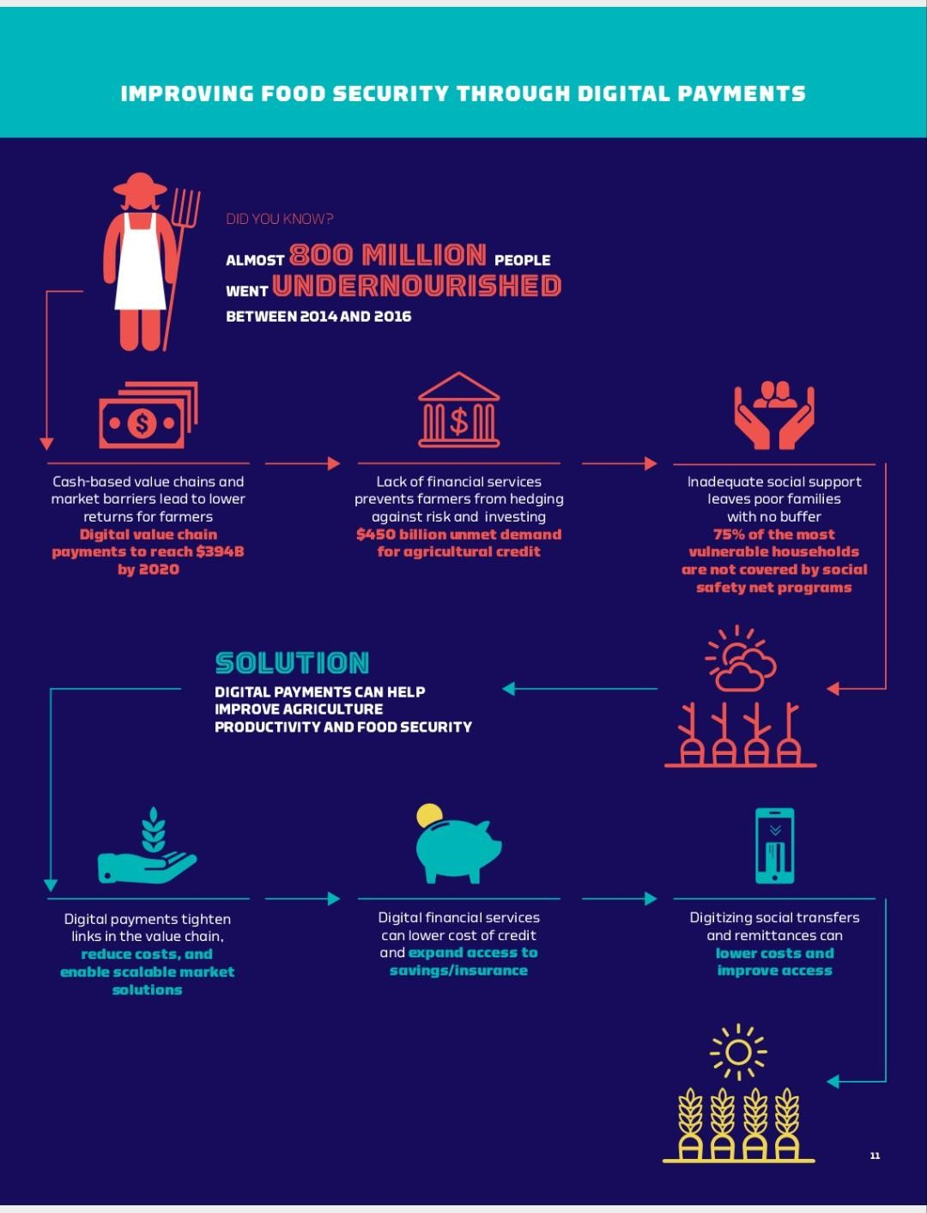

These are the three in principal barriers to improving agricultural sector efficiency and food security which can be addressed by African Digital stable coins’ payments.

Cash-based value chains and inefficient markets

* Agricultural value chains entail numerous transactions between all types of stakeholders: farmers, input sellers, creditors, local buyers, global agribusinesses, and others. The high volume of transactions creates a multiplier for any inefficiencies, such as cash payments.
* In addition, many farmers incur considerable risks when selling their crops due to information asymmetries and other barriers.
* Digital payments help by shortening transaction times and improving transparency through quicker, traceable payments. For agribusinesses procuring from a single farmer or large group of farmers (cooperative) digital transactions/ecosystem offer greater security, market assurance, speed, and efficiency.
* At the same time, a new payment channel could facilitate the establishment of digital marketplaces or a virtual trading floor for farmers, allowing them to sell their crops directly to the federal government which supplies Travers/wholesalers and also aiding logistics arrangements to deliver the produce to markets or processing plants accordingly to the traders/wholesaler's or companies description.
* Mobile industry association GSMA estimated that the potential market for digital value chain payments would reach US$394 billion by 2020, paid to 370 million farmers.

Lack of non-payment financial services suitable for smallholders.

* Financial service providers have struggled to meet the needs of smallholder farmers, due to their volatile incomes and low density.
* Digital payments facilitate access to financial services for smallholder farmers by lowering transaction costs, providing flexibility, and improving the customer experience. This is critical to building a business case for financial service providers in rural areas; and as for the African Digital stable coin, market is a guarantee.
* Demand for just agricultural credit has been estimated to be as high as US$450 billion.

Inefficient delivery of social programs and remittances

* Social protection, whether it be in the form of private remittances or public transfers, is necessary to maintain food security.
* Unfortunately, 73% of the world’s poor lack the social support structures necessary to assist them during inevitable food shortages, and three quarters of the most vulnerable households are not covered by a social safety net program.
* Digital payments can help improve the efficiency of social program delivery by reducing costs and leakages for government transfers aimed at the rural poor.

The African Digital stable coin is a priority action for Using Digital Payments to Improve Regional and Global Food Security, Agricultural Productivity and value addition; analyzing the business case for digitizing aspects of the value chain, including bulk payments to farmers or credit to suppliers, Working together to identify the existing food aid, cash transfers, and subsidies that benefit smallholder farmers and making it more efficient through digitization; encouraging adoption of a Gold backed digital currency by incorporating it's benefits using the existing channels for agricultural education.

1. Unlimited bilateral trade.

Likened to the lungs, as it involves the exchange of goods and services between different markets and countries. The African food program distributes agricultural produce according to real-time market demand and supply data, ensuring a balanced trade system, much like the lungs and kidneys maintain balance in the body. The international trade aspect involves trading with countries that observe the gold standard, ensuring a stable and fair trade system.

Subjective Value and Gains from Trade

We begin the introduction to this financial value system by getting clear on some foundational concepts. We consider the nature of our choice back up value which is Gold and agricultural produce for the AD stable coins[66grams gold coin], which gain automatic trading rights immediately they are purchased from the bank, each coin will receive a 10% profit of every trade, unlimited possibilities of wealth creation.

Value Is Subjective

Among the most important concepts in financial management is that different people spend on and value things differently. For example, ome people love seafood; others dislike it. Some enjoy watching football; others prefer old movies. Tastes in music vary widely. And the same person values the same thing differently in different times and situations. The value you put on a nice meal, for example, depends on how recently you last ate.

The term we use in economics for this fact is that “value is subjective.” Value is in the eye of the beholder, so to speak; it is in the person, the subject doing the valuing rather than in the object being valued.

Subjective value stands opposed to the older labor theory of value: the mistaken view (articulated by Adam Smith in The Wealth of Nations and taken up by Karl Marx as one of the foundations of his economic theory) that the value of any good is determined by the amount of labor required to produce it. A bottle of water, say, is held to be worth a dollar because a dollar’s worth of labor was required to obtain and filter the water, to produce the plastic of the bottle and the lid, to put the water in the bottle, and to produce and glue on its label.

But the labor theory of value is untenable. If it were true, then an apple pie that took four hours to produce would be worth the same amount as a mud pie that took the same four hours. It’s not, because people don’t like to eat mud. The tastes and preferences of the people doing the valuing are what determine something’s value.

According to Their Own Values

Value is subjective and has wonderful consequences: people can make one another better off merely through unlimited trading, through exchange. When Jimmy prefers Ted’s backpack to his own skateboard, and Ted prefers Jimmy’s skateboard to his own backpack, the boys can exchange backpack for skateboard and make each boy better off according to his own subjective values. In an important sense, each boy is wealthier after the trade. When fishermen in my home village of katosi trade fish to nabuta village vegetable growers for their vegetables, both groups are better off—wealthier according to their different values—as each group gives up what it values less for what it values more. Notice how this insight about the mutual benefits from voluntary exchange contradicts the widespread notion that exchange is zero-sum, that in a market economy, some people benefit at the expense of others. The notion is there in the expression “the rich get richer and the poor get poorer.”

That implies that the rich get rich at the expense of the poor. We hear “one man’s loss is another man’s gain,” as if there is only a certain amount to go around, so that if one person becomes better off, someone else must have become worse off. Underlying a lot of the animus against “haves” is the notion—perhaps unconscious and unexamined—that the wealth of “haves” comes at the expense of “have-nots.”

But that is not true, as long as the wealthy earn their wealth in voluntary exchange (rather than through special privileges from government, such as bailouts, subsidies, or protected. Consider Steve Jobs, LeBron James, and Beyoncé. They are all “haves.” Did they become wealthy at the expense of the rest of us? Not at all. They became wealthy by delighting us with their electronic devices, athletic prowess, and great songs and videos. To Conclude; structuring, organizing and controlling unlimited bilateral trade through the African Digital stable coins between the seven states and other willing African states; robust social and financial transformation of the East African community and Africa.

# OPERATIONS PLAN

*The African Digital Coin physical structure (physical coins) is establishing its value on Gold; this principle is adding value three hundred and sixty degrees. Gold is an Element valued in weight and so will our units of price be re-evaluated by gold weight and also the same weight will be considered in the financial structure of the digital currency.*

## AFRICAN DIGITAL COIN TRADE AND MARKETS

CREATE, STORE AND SHARE REAL WEALTH.

------------------------------------------------------------------------------------------------------------------------------------------

AGRIC

TRADE

GOLD

TRADE

UNLIMITED

TRADE AND

MARKETS

# GOLD BASE AND TRADE

Who is out to make some profit?

The highest bidder is the only one apparently who is going to make the profit in this case, not everyone it seems; we all asked, what is the term and who is termed as “the highest bidder” and who are they, him or her, it has to be someone. In my findings, this is a party or individual that is willing to pay any price for anything that is at stake, why; because of the value they see [the hidden value] according to their mindset; the value the highest bidder see’s or holds exceeds the rest they are bidding with, and the highest bidder is not bothered about the price to be paid, for most often they offer more money than the original price just to express their purchasing power and also reduce or totally eliminate any competition at hand; it’s a form of monopoly, and above all factors they have surety for what they are highly bidding for; it will multiply 99 times the amount it is purchased, so who is on top of the high bidder’s value chain? We can trace his footsteps when we visit the international gold market and its history, were all the gold the world can offer is bought with no hesitation no matter the price, there I found Saudi Arabia and they pointed me to the United States of America [USA], and the USA pointed at [JPMorgan] “the god of the American banking system” and also the highest bidder I was looking for; I also learnt When his gold supply is low, and his demand is always high; he raises the price he is buying the gold to illustrate his demand and attract him-self more suppliers too. He is the world’s gold market price regulator. Not only that; he comes back to the people who supplied to him the Gold and collects back 99 times the value he used to purchase it initially; we pay the price back ninety-nine times.

“The apples of Gold in pictures of silver- Nsadhu Marvin”

# AFRICAN DIGITAL COIN VALUE ORGANISM

The African digital coin was created to boost and build financial immunity and independence in the agricultural production and trade spheres managing directly their prime or primary factors of trade to eliminate all forms of trading inequalities and also improve the trading processes through comprehensive digital approach, bellow is our gold, agro and trade based currency and its value chain;

1

. The African

Federal Bank

-

buying all gold available to buy at

the international price.

-

mint

coins, upload and resale in digital

form to citizens and Gold

exporters.

2

. Citizens and Gold exporters buy

the digital coin [ when the coin is

no

-

longer owned by the bank, it

gains unlimited bilateral trading

rights]

. Coin is used to purchase

3

agriculture produce directly

from farmers; this is done

by the bank on

their behalf.

4

. The produce bought from the farmers is

sold to registered whole sale traders

[

regional

and international] or agro

processing plants with a minimal profit

Margin[10%] for the citizen owning the coin.

The trader will direct were[markets] the

produce is to be delivered.

5

. Retailors registered digital in the

markets will get notifications

about all good coming [in transit]

to their markets and will be able to

place a booking accordingly and

complete transaction when the

goods are delivered to the market.

6

. Retailors sell their produce to the

final consumer; general population.

ABOVE: The African Digital Coin gold, agro and trade based currency and its value series.

1. [Gold traders, Gold miners, gold exporters and the Bank]

AFRICAN

MONITORY

FUND

AFRICAN

FEDERAL

BANK

AFRICAN

FEDERAL

RESERVE

ABOVE: The chief organization structure of the African Digital Coin.

The African federal bank- will be mandated to purchase Gold at the international price- and mint [66grams-

100% pure] Gold coins- 15 coins per kilogram- the coins are kept in the African Federal Reserve- each coin entering the reserve bank is giving a microchip with a special IP [internet protocol] address - upload the IP address online as a digital stable coin- every coin uploaded is managed by the African federal bank- the federal bank sells the coin to the citizens or gold exporters- once the digital coin is sold it gains unlimited trading rights.

1. [Citizens, Gold exporters and the Bank]

Gold exporters will have a unique arrangement-once they have opened up an exporters account with the bank- they can purchase the amount of coins allocated by the bank for export- the coins to be exported are only obligated to 12 complete trades- the exporter will receive 70% of the profits made during the trading cycles-when the trading cycles are completed, the exporter can withdraw the coins from the African Federal Reserve plus their trading profits- the citizen has unlimited trading rights- the citizen receives 90% of their trading profits instantly at the end of every trading process.

1. [citizens, Farmers and the bank]

The African digital coin is mandated to purchase all agro produce of an acre or more from the farmers directly at a standard price- the “African food program” will handle the produces’ storage and logistic on behalf of the trader- the trader will incur minimum logistics costs- the funds used to make these purchases initially from the farmer are citizens’ digital coins- the African food program will purchase all the surplus produce.

1. [The Bank, traders and markets]

All regional and international agro traders [ in our digital system] and out sourcing agro processing organs will buy from the bank and designate the market center/location where the produce is to be delivered in the case of wholesale traders, agro processors with their own logistics infrastructure will access their purchased produce at our designated African food program warehousing storage facilities-they will incur no logistical costs.

1. [Traders, markets and retailers]

A digital market system [that connects markets, traders, wholesalers and retailers] will send digital notifications to all the retailers in and around the designated market centers where the produce is heading particularly, giving them an opportunity to place in their bookings with the trader digitally and complete transactions when goods are delivered to the designated markets.

6. [Markets, Retailers and the final consumers]

The retailers buy from the traders and will sell the produce to the final consumer and so the agro processors.

-------------------------------------------------------------------------------------------------------- --------- Below is an illustration of the African Digital coin digital eco system;

1.

The Bank, Gold

traders, Gold

miners and

gold

exporters

.

2

. Citizens,

Gold exporters

and the Bank

.

3

. citizens,

Farmers and

the bank

.

. The Bank,

4

traders and

markets

.

5

. Traders,

markets and

retailers

.

6

. Markets,

Retailers and

the final

consumers

.

AFRICAN

DIGITAL

COIN.

# COINAGE STRUCTURE AND VALUING ON GOLD

The development of the stable coins’ value structure is all based on the current economic value system of gold and silver, the United States Dollar and the Ugandan shilling. This is being done to reevaluate the Ugandan shilling after I peg it on gold and weigh it against the dollar again and all other existing fiat currencies.

To begin with, I considered all factors why one-unit price of the dollar a fiat currency is worth three thousand eight hundred units of the Ugandan shilling another fiat; the best way, I broke it down without complicating anything so replaced the same values with different units just to see the dynamics and reasonable possibility of this equation:

**1 US Dollar = 3800 Ugandan shillings**

**1 American = 3800 Ugandans**

**1 day in America = 3800 days in Uganda**

**1 hour in America = 3800 hours in Uganda**

**1 minute in America = 3800 minute in Uganda**

**1-second in America = 3800 second in Uganda**

**1-tree in America = 3800 trees in Uganda**

**You can be the judge.**

## CREATION OF THE AFRICAN DIGITAL [AD] COIN PHYSICAL VALUE STRUCTURE AND VALUING.

The creation of the Gold pegged Ugandan shilling:

[the figures used in the keys of these calculations have to be updated according to the local and international currency and gold volatility.]

### Key:

1 Dollar [USD] = 3800 Shillings [Ugx]

1 Kilogram of Gold = 65,000 USD

= 3,800 Ugx * 65,000 USD

One kg of gold in UGX = 247,000,000 Ugx

1 gram of Gold = 65 USD

1 gram of gold in UGX = 247,000 Ugx

The founder’s executive committee of the East African Youth Leadership Scheme proposed the physical structure weight of the African digital gold coin should be 66grams of Gold each.

1 gram of Gold = 65 USD

1 African Digital Coin [ADC] = 65 USD * 66 grams [ADC]

Price of 66grams of gold= 4,290 USD

= 4,290 USD * 3,800 Ugx

Price of 66grams of gold in UGX = 16,302,000 Ugx

We are calculating how many AD COINS of 66grams are in 1 kilogramme[1000g]

1 Kg of Gold has = 1000grams

1 AD Coin has = 66grams

1 Kg of Gold = 1000/66

= 15.15151515151515 [AD Coins are in 1kg of Gold]

After the coins are minted, 30% value added tax [VAT] will be added onto every gram of the coin.

1 AD Coin [Ugx] = 16.302,000 Ugx [without VAT]

= [30%*16,302,000] + 16,302,000

= 4,890,600 + 16,302,000

= 21,192,600 Ugx [ the market price of the AD Coin plus VAT]

[In US Dollar]

1 AD Coin [USD] = 3,828 USD

= [30%*4,290 USD] + 4,290

= 1,287 + 4,290

= 5,577 USD [ the market price of the AD Coin plus VAT]

# PEGGING THE UGANDAN SHILLING ONTO THE AD GOLD COIN.

## KEY:

1 US DOLLAR = 3,800 Ugx

1 AD Coin [66grams of Gold + 30%[VAT] = 5,577 USD

= 21,192,600 Ugx

-------------------------------------------------------------------------------------------------------------------------------

# WORKING

We are considering the factor of the Ugandan Shilling is being attached to gold [ADC], and then we weigh it against the dollar again and work out to equate the two currencies.

In this case, the Ugandan shilling ceases from being a fiat currency and the US dollar retains its fiat status; We round off to the nearest thousands to create a single digital

1 USD = 3,800 Ugx

1 USD = 3. 8 0 O

1 USD = 3.8 Ugx

We apply the mathematic principle of reciprocal; in this case we inverse the currencies only and not the numbers to put the lesser and greater currency in their new reevaluated place, the gold currency is greater and the fiat is lesser.

1 = 3.8

USD UGX.

1 UGX = 3.8 USD

**1 Ugandan gold pegged Shillings = 3.8 United States Dollars.**

This will result into the introduction or decree of new notes with single digits; i.e.

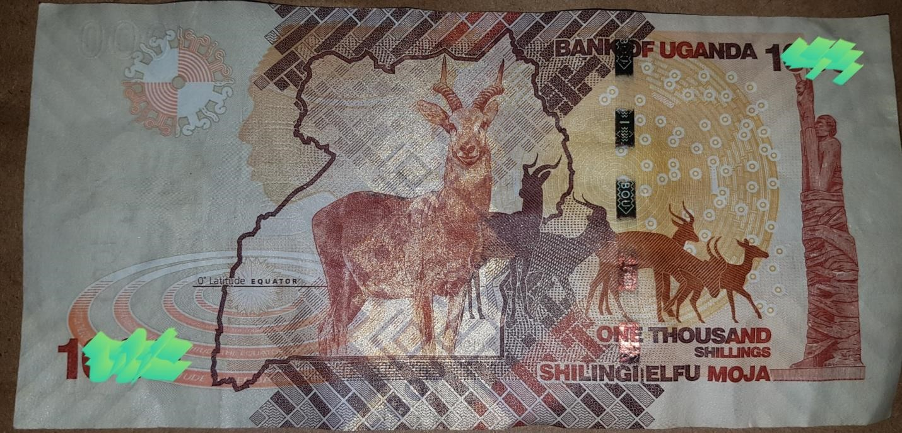

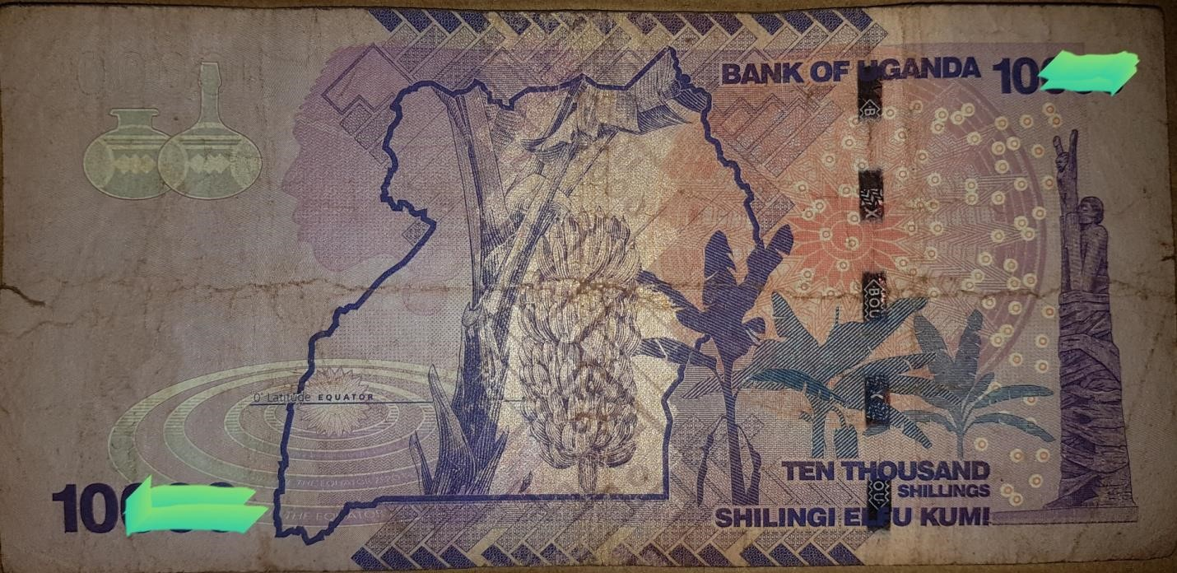

This implies the initial fiat local currencies have been weigh against the new gold pegged currency and we propose the creation of a new gold pegged bank note which will carry its own independent new gold value [1 gold SHS = 3.8 fiat USD] this will be the value of the one gold shilling note in comparison with the existing fiat Ugandan shilling.

1 US DOLLAR = 3,800 Ugx

1 AD Coin [66grams of Gold + 30% = 5,577 USD

= 21,192,600 Ugx

The value of the one Gold shilling [pegged on the AD Gold Coin]

**1 Gold Ugx = 3.8 USD**

Old local bank notes needed to buy the new gold pegged note;

1 Gold Ugx bank note = 3.8 USD * 3,800 SHS

**= 14,000 Ugx [old local bank notes]**

How many new Gold pegged notes [in amount] are needed to buy one AD Coin [66g of gold]

1 AD Coin [66grams of Gold + 30%[vat] = 21,192,600 Ugx

= 21,192,600/14,000

**1 AD Coin = 1,513.7571 Gold Ugx**

# TAXATION

The taxation value model of the African digital coin is unique and its basis is considering all value factors of financial systems as far as they have come; and above all considering the gold value system in relation to all

existing fiat currencies and their value organisms. Talking about fiat currencies our calculations model is

using the prominent US Dollar because it’s really on fiat to look out for, “three hundred million United States dollars were spent every day in the Afghanistan war for more than twelve years; we have positioned the US dollar as the highest fiat currency in circulation on the globe, and we based on this to impose a 30% VAT on every gram of the coin; we also have a proposal of which the local [East African community] currencies are imposed a lesser 15-12% value added tax when used to purchase the digital coin; also proposing an incentive that the African federal bank pays the 30% VAT for individuals and entities that are purchasing the digital coins with actual gold.

After the coins are minted, 30% or more value added tax [VAT] will be added onto every gram of the coin bought using US dollar, euro, and all other dominant fiat currencies.

1 AD Coin [Ugx] = 16.302,000 Ugx [without VAT]

= [30%*16,302,000] + 16,302,000

= 4,890,600 + 16,302,000

= 21,192,600 Ugx [ the market price of the AD Coin plus VAT]

[In US Dollar]

1 AD Coin [USD] = 3,828 USD

= [30%*4,290 USD] + 4,290

= 1,287 + 4,290

= 5,577 USD [ the market price of the AD Coin plus VAT]

[Buying Ad Coins Using Actual Gold]

1Kg of gold = 1000g

1AD COIN = 66g

1killogram of gold= 15 Coins

**1 AD Coin = 1,513.7571 Gold Ugx with 30% VAT**

# GOLDEN PEARL_ STOCK EXCHANGE.

-GPSE-

AFRICAN DIGITAL COIN

CREATE, STORE AND SHARE REAL WEALTH

Invest in Gold; and make profit in Gold.

# FOREWORD

Who is out to make some profit?

The highest bidder is the only one apparently who is going to make the profit in this case, not everyone it seems; we all asked, what is the meaning of this terminology and who is termed as “the highest bidder” and who are they, him or her, it has to be someone. In my findings, this is a party or individual that is willing to pay any price for anything they value more than others, why; because of the value they perceive [the hidden value] according to their mindset; the value the highest bidder see’s or holds exceeds the rest they are bidding with, and the highest bidder is not bothered about the price to be paid, for most often they offer more money than the original price just to express their purchasing power and also reduce or totally eliminate any competition at hand; it’s a form of monopoly, and above all factors they have surety for what they are highly bidding for; it will multiply 99 times the amount it is purchased, so who is on top of the high bidder’s value chain? We can trace his footsteps when we visit the international gold market and its history, were all the gold the world can offer is bought with no hesitation no matter the price, there I found Saudi Arabia and they pointed me to the United States of America [USA], and the USA pointed at [JPMorgan] “the god of the American banking system” and also the highest bidder I was looking for; I also learnt When his gold supply is low, and his demand is always high; he raises the price he is buying the gold to illustrate his demand and attract him-self more suppliers too. He is the world’s gold market price regulator. Not only that; he comes back to the people who supplied to him the Gold and collects back 99 times the value he used to purchase it initially; we pay the price back ninety-nine times.

***Golden apples in pictures of silver- Nsadhu Marvin African Digital Coin***

# INTRODUCTION

I

humbly dissect the organ and basically understand its function-ability, the analytic surgery is done with all seriousness; the “stock market” I perceived it is as a “scary abyss/gulf of money”; “stocks/share or equity”- [ are a financial token or instrument that signifies proportionate ownership [stockholder] in/of a company. This instrument entitles the stockholder to that proportion of the company’s assets and earnings/profits/dividends.] if you own a stock in a company, when the value of that firm grows so does your stock likewise when the company’s value declines.

There are two types of stocks 1-common stocks [they give the stockholder voting rights in the company on major decisions such as mergers and board elections] 2-preferred stocks [the stockholder has no voting rights in the firm] So the next thing is to find out why companies sell stocks; basically to get money/, stocks allow companies raise massive amounts of operating capital essentially with no extra effort or product. The current markets measure the value of the company according to its potential earnings in the near future which makes relatively smaller companies earn millions or even billions of operating capitals if investors think they can succeed in the future, so then if a company needs to sell stocks it needs a place to do it and that is entering the stock market.

How companies get their shares/stocks listed [on the stock market]- this is done when a company sells shares through an “initial public offering” [IPO] on an exchange/market, this changes the status of a company from being a privately held business to a public traded one, and when the stocks of the company are listed, then the public can start to trade them and usually the prices of the stocks volatility depends on the public opinion or the price to earnings ratio [P/E-RATIO] as well as other matrixes. Why and how stock/share prices fluctuate- the stock market is full of investors and individual traders who all feel different ways about a company, they all make different choices and those choices result into the positive or negative movement of a stock; if more people buy then the price has to climb and when people are buying out of the company so will the price fall; this generally uncertain fluctuation is all possible because of one thing, “fiat currency” and billions of investors’ funds have been swallowed up in these bubbles; and so it is advised to invest the money you are okay to lose so that we you do lose it, you are just fine with it; and this is where we come to distress with the current stock market structures.

# EXECUTIVE SUMMARY

The “Golden pearl stock exchange” (GPSE) stemming the name from the abundant Gold enriched in the African soils and “the pearl of African” [Uganda] where the brainchild of the African Digital Coin calls home, located in the heart of the beautiful African continent; the GPSE was developed to firmly be “a fiat currency immune stock market” which is solitary mandated to attend to all companies, organizations, start-ups and corporations which will be expending on a day to day basis our gold pegged African digital coin financial eco-system.

Unlike all the existing exchange[stock] markets, the value system to be used in determining how much each share will cost and how many shares to be sold by a company, the GPSE will take the pleasure to carry out a forensic audit of any firm before listing it on the market for the public to start purchasing its shares; why, to offer reasonable responsibility to all who would love to invest in the companies listed on our market, making surety to the public that investing in any firm listed on the GPSE market is a good deal to take thus saving the investors time that is taken in other markets to audit the company’s listed before buying stocks from them, also mitigating all the risk factors of a bad investment. The cost of each share will be determined by audit which will be related with the firm’s development agenda in cost and the final cost will be automated to grow and fall as the company’s Capita per income (CPI) variation.

The GPSE thoughtfulness criteria for the firms that apply to be listed on the market, for securing the public from all possible bad investment options, GPSE will conduct an integrity audit of the firms before verification into the exchange market, the GPSE will carry out this task to confirm the purity of the business intentions/objectives of each firm. This service will be an incentive for the investors on the market and also aid to eliminate and mitigate bad investments; a risk analysis will be carried out by GPSE on behalf and for the wellbeing of the investors {public} in our market right from the start before it is known when our investors shares are mislaid. The GPSE is to do all in its ability to make sure investors {public} are sure of investing in any firm listed on the Golden Pearl Stock Exchange.

# GPSE STOCK/SHARE VALUE AND PRICING MECHANISM

The share value system of the GPSE will consider the total assets cost **[T.A]** 1 Gold SHS = 3.8 USD[14,000 Ugx], {as for this document we shall use the current fiat currencies for elaboration and quick configuration} we shall consider total money in the bank **[T.B]** [AFRICAN FEDERAL BANK-bank statement] and the firms balance sheet **[B.S]**.

***The GPSE will scrutinize the development plans of the firms applying to join the market [ strategic development plans are a must provide for consideration into the value process of the GPSE] if the development plan [DP] presented is found lucking, recommendations will be made and provide to all rejected firms, the firm will be given an opportunity to defend its DP to the GPSE. A final decision will be made after considering the applying firms DP defense presentation, the final decision will be published through a special report to communicate both the company’s declined or acceptance into the market; the report will contain the GPSE’s detailed analysis for the firms declined or verification to join the market and if a firm will be rejected the second time after its defense, final recommendations will be communicated and if adopted by the firm then it can be listed once its confirmed by the GPSE.***

## GPSE MATHEMATICAL VALUATION MECHANISM

|  |
| --- |
| We are going to create a firm called **“Kaguta Foods”** It’s going to be taken though the GPSE stock valuation mechanism, at the end of this process we shall be certain how many shares are to be sold and at how much is each share per capita; once the share price is determined, it can only grow [fluctuate] mimicking the firm’s growth margin only. |

The GPSE is going to take KAGUTA FOODS through our mathematical value mechanism of find out how many shares the firm is to sell and the price of each share to collect the necessary capital according to their DP which we found authentic, reliable, sustainable and

environmentally friendly.

**Key:** The total assets cost **[T.A] = 1,500,000,000 Ugx** Total moneys in the bank **[T.B] = 550,000,000 Ugx** Balance sheet **[B.S] = 2,500,000,000 Ugx**

Development plan cost **[D.C] = 7,000,000,000 Ugx** [most valuable figure in our calculation]

1. Determining the new share % of the original shareholders[OSP].

OSP = T.A + T.B

OSP = 1,500,000,000 + 550,000,000

OSP= 2,050,000,000

OSP % = [2,050,000,000 ÷ D.C]100

OSP % = [2,050,000,000 ÷ 7,000,000,000 ]100

**Original Shareholders Percentage =29.2857%**

*The GPSE proposes a 10% increment to the OSP % as an incentive and in honor of the work done and work to be done once the firm enters the market.*

OSP % = 29.2857 + 10

**New OSP = 39.2857 %**

1. Share percentage to be sold on the exchange [EMP-Exchange market percentage].

EMP % = 100 - 39.2857

**EMP = 60.7143 %**

1. Dividends

All profits that Kaguta foods will make once it enters the GPSE will be proportioned according to this % ratio respectively;

**[New OSP: EMP] %**

**[39.2857:60.7143] %**

1. Stock quantity [S.Q] and Lowest stock price [LSP]

*The GPSE proposes the lowest share price*

*[LSP] on the exchange should be 120,000 Ugx*

LSP= 120,000 UGX

&

S.Q = DC ÷ LSP

S.Q = 7,000,000,000 ÷ 120,000

**S.Q = 58,333.3 [shares/stocks] to be sold by Kaguta Foods.**

1. Com-mon shares and preferred shares

There are two types of stocks 1-common stocks [they give the stockholder voting rights in the company on major decisions such as mergers and board elections] an investor who will attain this stock status/rights they must have exactly or more than 317 S.Q’s and implying all who purchase bellow that they automatically stated as 2-preferred stocks [the stockholder has no voting rights in the firm].

The Golden apples in pictures of silver

# FOREWORD

I heard my dear president of the republic of Uganda H.E Yoweri Kaguta Museveni mentioning on many occasions about “the state’s need to increase on the level of foreign currencies”, and he also made it clear why he needs these fiat dollars and pounds; I personally analyzed it as an actual financial problem. Prior to this point, I had a heated debate with my friends doing forex trading and I expounded to them how the forex trading system was developed to back up and sustain the dominant fiat currencies, and also it is designed to assert systematic financial oppression on other fiat currencies. So I used the information I had at that point and did more research on financial structures and systems right from the first financial civilization which is Egypt; the first global financial power to the current. I started right away to develop the African digital coin with all the valuable data I had collected with a prime objective of financial freedom of the country and continent from our desperate need and dependence on the foreign fiat currencies. I underline a problem I noticed, “exported inflation” in all aspects of our financial framework locally and internationally; developing a new gold pegged affluent financial model from the local value structure of our shilling and international position of the shilling against the dollar and gold a natural resource; there I gave birth to the “African digital stable coin” to encounter and reverse the issues at hand and offering a comprehensive and permanent storage of value of our financial systems and aiding intensively both the region [East African Community] and African continent enjoy financial freedom.

***Nsadhu Marvin***

***[Founder and chairman founders’ executive committee –East African youth leadership scheme]***

## The apples of gold

Gold in the EAC is exported at the price of 40-50,000 us dollars and sold in other economies at 65000 USD at this point. The visible value EAC exports to the destination market is 15-20,000 USD on every kg of gold plus something I define as “the hidden value” that I would love us to look into; there is hidden value in gold, it’s only visible to those who have knowledge about adding 99% value on every unit of 1kg of gold; no matter the price of a kg of gold is, them who know about the hidden value will pay for it knowing surely they will attain back the initial investment 99 times. So I ask, do you think we don’t need that value more than the person we are selling the gold or we are ignorant about “the hidden value” and the only value we see are the Dollars or Euros we are paid on sale of gold; the other question I asked myself, don’t we really need this value that we export with the gold, because I terribly learnt that they come back for the money they paid the gold for and we pay it back 99 times; and I also came to acknowledge its done in a regulated and ethical business environment were what I am talking about is regarded as business profit; very legitimate.

Who is out to make some profit?

The highest bidder is the only one apparently who is going to make the profit in this case, not everyone it seems; we all asked, what is the term and who is termed as “the highest bidder” and who are they, him or her, it has to be someone. In my findings, this is a party or individual that is willing to pay any price for anything that is at stake, why; because of the value they see [the hidden value] according to their mindset; the value the highest bidder see’s or holds exceeds the rest they are bidding with, and the highest bidder is not bothered about the price to be paid, for most often they offer more money than the original price just to express their purchasing power and also reduce or totally eliminate any competition at hand; it’s a form of monopoly, and above all factors they have surety for what they are highly bidding for; it will multiply 99 times the amount it is purchased, so who is on top of the high bidder’s value chain? We can trace his footsteps when we visit the international gold market and its history, were all the gold the world can offer is bought with no hesitation no matter the price, there I found Saudi Arabia and they pointed me to the United States of America [USA], and the USA pointed at [JPMorgan] “the god of the American banking system” and also the highest bidder I was looking for; I also learnt When his gold supply is low, and his demand is always high; he raises the price he is buying the gold to illustrate his demand and attract him-self more suppliers too. He is the world’s gold market price regulator. Not only that; he comes back to the people who supplied to him the Gold and collects back 99 times the value he used to purchase it initially; we pay the price back ninety-nine times.

***The deep calls onto the deep, who has heard the call?***

### Pictures of silver.

So how does it really add up to this; I will break down what I observed to you. The Arabs in search for water by means of digging underground wells were surprised find a thick black substance instead of water; they sought out to find out what manner of substance is this; it was “crude-oil” a shocking discovery they had in their hands. This inspired the first economic relationship between the Arabs and the United states of America. The USA was offering the Arabs the best they could in exchange for the crude-oil, and this was the “United States Dollar [$]”. The Arabs where informed that [USD] is the most powerful currency on the planet that can buy them everything and anything they ever wanted from any economy and assured that the US dollar is the “world reserve currency” pegged onto gold in the United States of America’s federal Reserve Bank. Am not sure if the Arabs were taken to see the vast gold reserve of the United States of America before they went on with the exchange, IN 1962 the united states started importing crude oil from the Arabs, paying them with the “world reserve currency-pegged on Gold” [US Dollar] and after nine years of transactions in 1971 President Richard Nixon unpegged gold from the dollar making It a fiat currency. I can understand it that information was not global as it is now, for the Arabs were ignorant for a while of these economic events that happened in the United States of America if not so, they didn’t understand the social and economic implications.

During the transaction period that started in 1962 the dollar was accepted by the Arabs, a deal was made; billions in cash where printed and allot of cotton and paper was used to ensure the payment to the Arabs; there happens the “Arabic economic boom”. The united states also offer a profit repatriation proposal which was availing social and economic development contractors that will help the Arabs to transform into something familiar or related to the American dream in the desert they dwell in. the Arabs where pleased and got 99percent of the social and economic infrastructure development contracts. This offered very many Americans in the deep state first and the general population in a few years, many prospered for there was a dollar rush in the United Arab Emirates. After a few years’ fiat profit repatriation into the United states, it caused a hyperinflation in the United States of America, the first solution according to the time was to start up mega projects and the most prestigious one was “the American twin towers”, but still the inflation was still on for the same fiat currencies were used to pay for these projects, increased flow of fiat currency always causes inflation; always.

The Arabs got the best roads, hospitals, schools, shopping malls, hotels and restaurants, business centers, leisure and recreation centers, banks, real estate and everything that the desert desired. The fame of the desert paradise went abroad and it created insecurity among the Arabs, for their success and developments had no security plan to ensure the safety of the people and their property; so they turned to their economic partners and expressed their need for all-round security partnership and willing to make all payments necessary using the same dollar that was given to them; “the international reserve currency”. During the hyperinflation the USA had in remembered the need of more gold in their economic value chain but could not do it legally or openly for that meant every dollar that was ever printed has units of actual gold in the federal reserve bank which was totally impossible; so the united states and Arabs find themselves in this state of indecision and one of them needs gold, and the other in need of security developments.

The united states were not willing in the first place to offer their security developments to any other nation, for it was meant for their security sovereignty; I am not sure the exact individual who proposed what about to write, for am certain the general population was ignorant about these decisions; the USA asked the Arabs to make their payments in gold for all the security developments they needed; directed to use the same dollars they want to use to make this purchase, to buy gold from the whole world and use that gold for the payment instead of the initial paper and ink dollars, and the price to which they valued each unit of gold in dollars was set forth to them [international gold price]. It wasn’t pleasant for the Arabs to learn that what was introduced to them as the international reserve currency only to be rejected by its issuer, and also being also obligated to use the US dollar to buy gold in the world and use it as a currency to purchase anything concerning National security developments from the United states of America. The Arab league was disturbed about this hypocritical offer by their economic partner who also made them his undeliberate gold broker, they really had not much of a choice to make for they really needed to get security superiority for the sake of their people and wealth.

A testimony of time and a lesson for all leaders who love their people have to learn. Judge not a man according to the flesh, and love your neighbor as you do thy self.

That which you desire for yourself is what you should do unto others.

***Responsibility is a blessing; only for the servants above them all [STEWARDS].***

A number has asked me, “why are you carrying such a responsibility, above all why you; you don’t seem fit to be the man to solve such a great puzzle.” Never judge a man according to the flesh, not even yourself; for you can do exceedingly than what you thought you could ever do, God is good.



*Peace be with you all.*